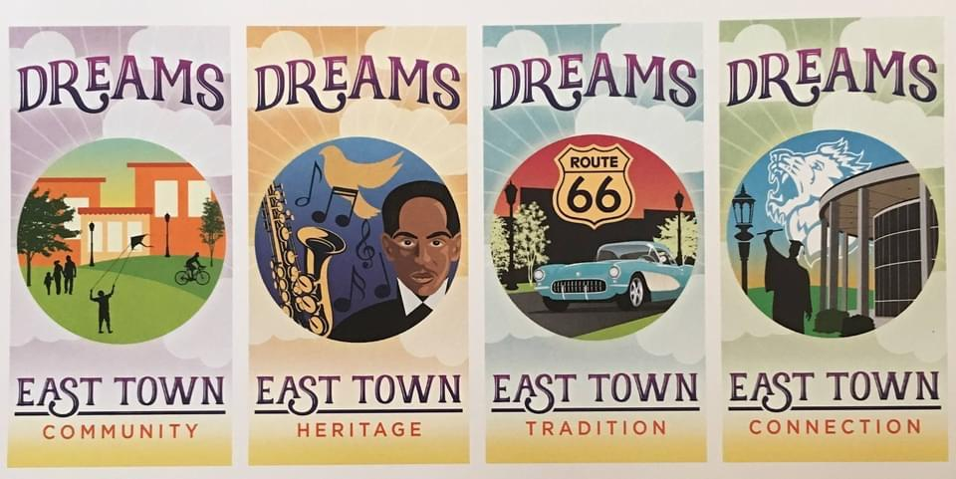
EastTown Dreams District
1203 Broadway Street, Joplin, Missouri 64801 cfozarks.org/hopepark
Melodee Colbert Kean, Scott Clayton, Brent Baker, Lisa Colbert, Doris Lewis, Asst.

Joplin Regional Black Expo 2021; Presented by EastTown Dreams District
Registration Form – please complete all information

Name (s) _______________________________ Phone # _________________________

Email __________________________________________________________ (print neatly)

Description of Craft/Business _________________________________________________
_________________________________________________________________________

Description of Display or Food Sample (If you are supplying food samples, please bring enough for 200 attendees)
_______________________________________________________________________________________
_________________________________________________________________________

Number of spaces ____________________ x Fee = $______________
Please try to limit your space to max 2 Tables and 4 Chairs
(Please make every attempt to register prior to March 31, 2021)

Payment can be in the form of Business Check/Money Order, Cash App., Pay Pal or Face Book Payment.
If writing a Business Check make your check payable to, EastTown Dreams District Black Expo 2021

VENDOR MUST SUPPLY TABLE(S), CHAIRS, AND ELECTRICAL CORDS

Please state any special needs. We will do our best to accommodate your needs. However, guarantees cannot be made. ________________________________________________________________________________________________________________________________________________________________

1

INSURANCE

A valid Certificate of Insurance shall be delivered to the EastTown Dreams District representative at least ten (10) days prior to Expo 2021. The coverage shall include contractual liability. Said policy or policies shall cover all activities taking place during the event.

The insurance must be from a duly licensed insurance company authorized to do business in the State of Missouri.

TERMS AND CONDITIONS

(Name of individual/organization/business/group/sponsor) will be financially responsible for any and all damages to the building/contents/premises that results from its use of the facility, including property damage, structural damage, and personal injury by ___________________________________________________

(Name of individual/organization/business/ group/sponsor), its guest, employees, agents, volunteers or subcontractors which occur in the course of use of the building/premises during the Black Expo 2021

Smoking within the building is strictly prohibited.

Vendors can begin setting up at 3:00 pm, Saturday evening, June 19, 2021 in the Joplin Empire Market. Please park in the rear of the building.

50% Refunds will paid up to April 30, 2021. Refunds will not be paid to vendor, no exceptions, after May 15, 2021. Thank you for understanding.

Please send your Registration Form and Check Payment No Later than March 31, 2021 to:

Doris Lewis, Assistant
202 S. Woodmont Drive
Joplin, MO 64801
dorislewis47@yahoo.com

Thanks for your support

